Final Exam

1) Basic C++ programming language commands
Code.

#include <iostream>

// Recursive function to compute GCD using Euclid's algorithm
int gcd(int a, int b) {
if (b == 0)
return a;
return gcd(b, a % b);
}

int main() {
// Test case 1: 513 and 39
int a1 = 513, b1 = 39;
std::cout << "GCD of " << a1 << " and " << b1 << " is: " << gcd(a1, b1) << std::endl;

// Test case 2: 1812 and 210
int a2 = 1812, b2 = 210;
std::cout << "GCD of " << a2 << " and " << b2 << " is: " << gcd(a2, b2) << std::endl;

// Test case 3: 1533 and 133
int a3 = 1533, b3 = 133;
std::cout << "GCD of " << a3 << " and " << b3 << " is: " << gcd(a3, b3) << std::endl;

return 0;
}

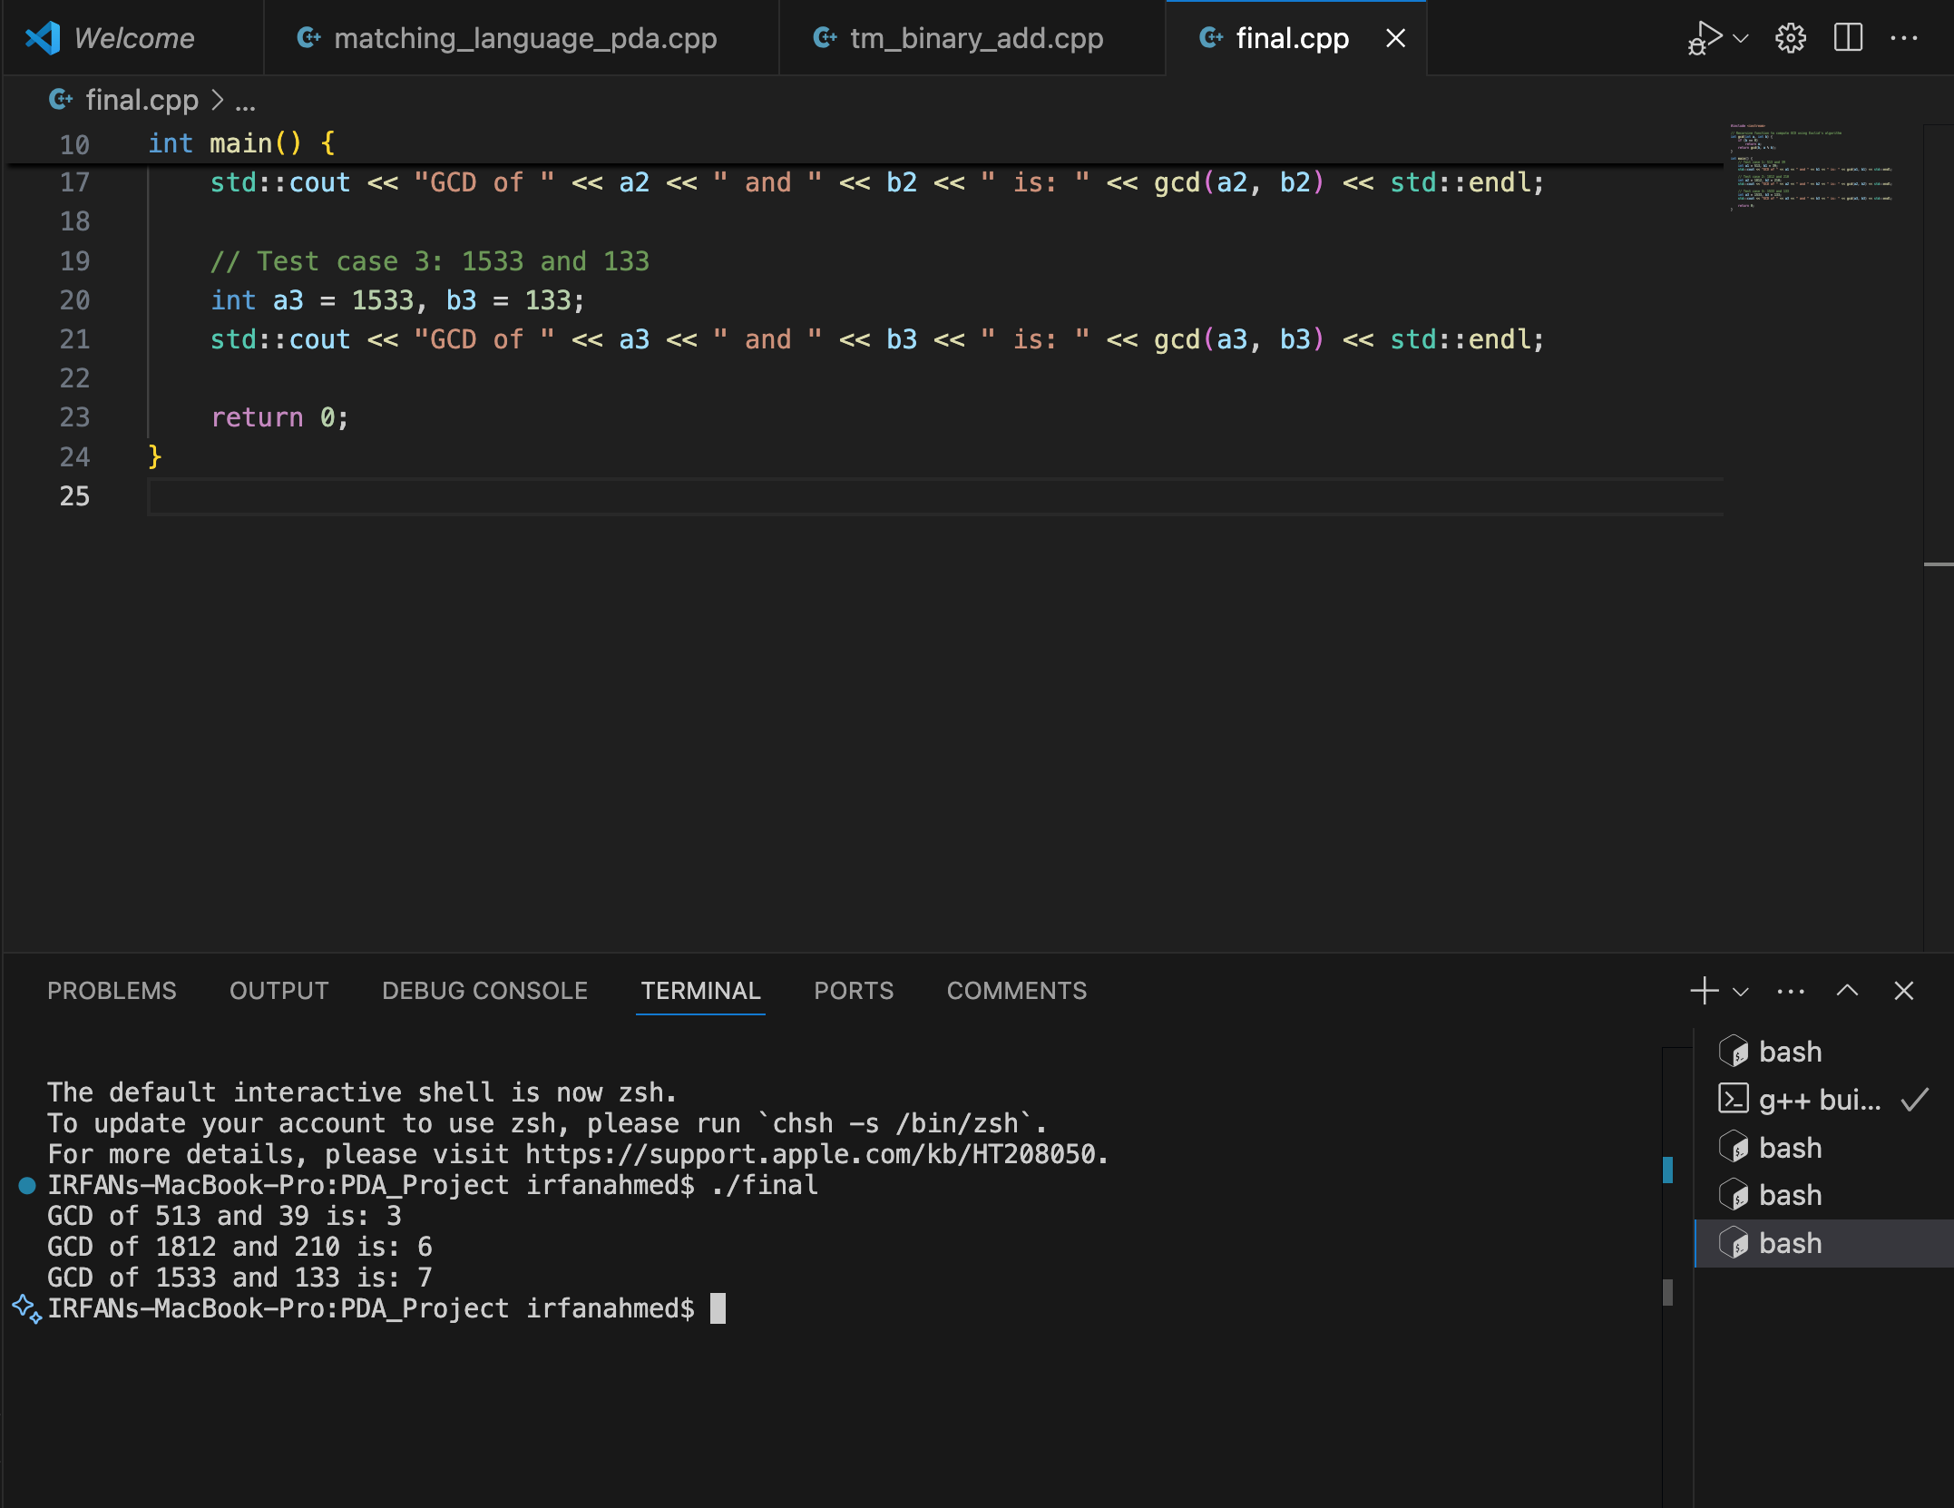

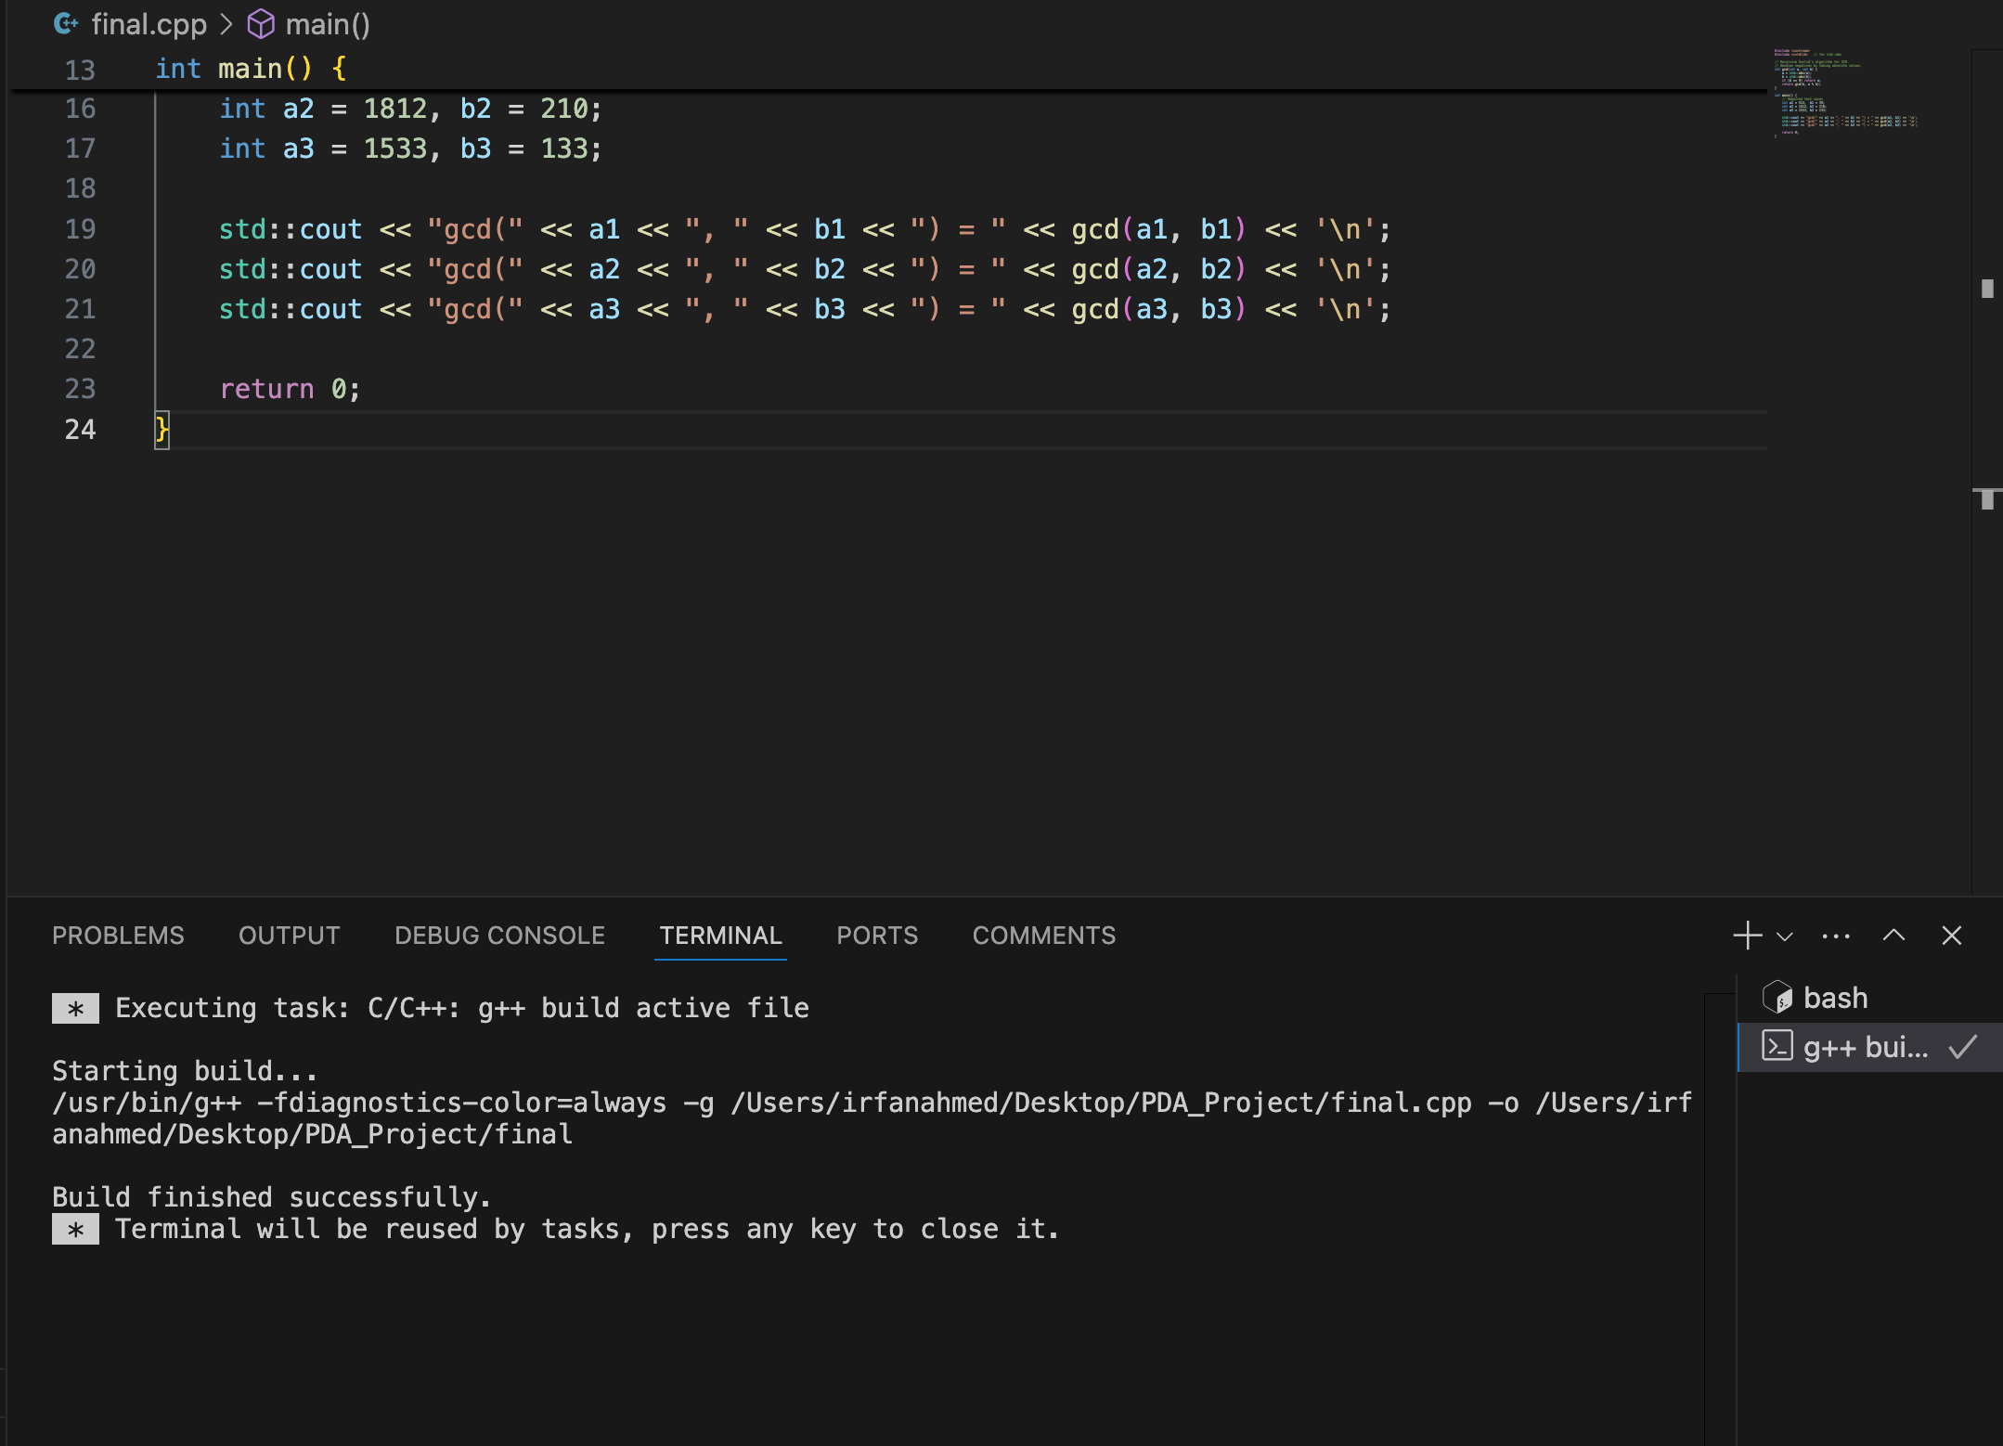

2) C++ programming language development
Code under analysis

#include <iostream>

class Full_Date {
public:
int m = 1;
int d = 1;
int y = 1;

Full_Date() {
y = 2000;
}

Full_Date(int mon, int day) {
m = mon;
d = day;
y = 2020;
}

int getM() const { return m; }
int getD() const { return d; }
int getY() const { return y; }

void setY(int yr) { y = yr; }
};

int main()
{
Full_Date d1(3,14);
Full_Date d2;
d1.setY(2012);

std::cout << d1.getY() << " and " << d2.getY() << std::endl;

return 0;
}
``

A) What will be printed when the code executes?
Answer:
2012 and 2000
Reasoning:
- d1 is constructed with the parameterized constructor Full_Date(3,14), which sets m=3, d=14, and y=2020. Then d1.setY(2012); changes only the year to 2012.
- d2 is constructed with the default constructor Full_Date(), which leaves m=1 and d=1 from the in-class initializers, and sets y=2000.
- The cout prints d1.getY() and d2.getY(), i.e., 2012 and 2000.

B) Simplest way to set a Full_Date variable to January 26, 2020
Answer:
The existing parameterized constructor, which sets y to 2020 by design:
Full_Date jan26(1, 26); // m=1, d=26, y=2020
This is the simplest and most direct approach given the current class behavior (the two-argument constructor assigns y = 2020 internally).

C) Empty constructors in Full_Date
C. Are there any empty constructors?
Answer: No.
There is a default constructor, but it is not empty—it assigns y = 2000:
Full_Date() {
y = 2000;
}
C.a) If there is(are), in which code line(s)?
Not applicable (no empty constructor exists in the provided code).
C.b) If there is not, how would an empty constructor look?
Two idiomatic options :
// Option 1: explicitly empty body – relies on in-class initializers (m=1, d=1, y=1)
Full_Date() { }

// Option 2: request the compiler-generated default constructor
Full_Date() = default;
With either empty/defaulted constructor, the in-class initializers (m=1, d=1, y=1) take effect, so the object would be (1,1,1), not (1,1,2000). The current non-empty default constructor deliberately overrides y to 2000.
D) Can we insert
std::cout << d1.m << std::endl; after the declaration of d2 (your “line 28”) without error?
Answer: Yes, it will compile and run as the class is currently written, because the data members are under public:.
D.a) What will it print?
It will print the value of d1.m. Since d1 was created as Full_Date(3,14), d1.m == 3, so:
3
D.b) If (hypothetically) it could not, how to fix?
If the members were declared private (a common encapsulation best practice), direct access would fail. The correct fix would be to use the accessor:
std::cout << d1.getM() << std::endl;
Summary
- A. Output: 2012 and 2000.
- B. Full_Date jan26(1, 26);
- C. No empty constructors.
  - C.a) N/A.
  - C.b) Full_Date() { } or Full_Date() = default;
- D. Yes, it can be inserted.
  - D.a) Prints 3.
  - D.b) If members were private, use std::cout << d1.getM() << std::endl;.

3) Finite State Automata

Finite State Automaton (FSA) Analysis
Given FSA Description
- States: {0, 1, 2, 3}
- Initial State: 0
- Final State: 2
- Alphabet: {a, b}
- Transitions:
  - 0 → 1 on a
  - 0 → 3 on b
  - 1 → 2 on b
  - 3 → 2 on b
  - 2 → 2 on a or b (self-loops)

A. Three 4-letter words accepted by this FSA
A word is accepted if:
- It starts at state 0.
- Ends in state 2 after reading all letters.
Reasoning:
- To reach state 2, we need:
  - From 0 → 1 on a, then 1 → 2 on b, OR
  - From 0 → 3 on b, then 3 → 2 on b.
- After reaching state 2, any combination of a or b is allowed (due to self-loops).
Examples:
- abba
Path: 0 -(a)-> 1 -(b)-> 2 -(b)-> 2 -(a)-> 2
- bbaa
Path: 0 -(b)-> 3 -(b)-> 2 -(a)-> 2 -(a)-> 2
- abbb
Path: 0 -(a)-> 1 -(b)-> 2 -(b)-> 2 -(b)-> 2

B. Three 4-letter words NOT accepted by this FSA
A word is rejected if:
- It never reaches state 2, or
- Ends in a non-final state.
Examples:
- aaaa
Path: 0 -(a)-> 1 -(a)-> (no transition)
- bbbb
Path: 0 -(b)-> 3 -(b)-> 2 -(b)-> 2 -(b)-> 2 ( This is accepted, so not valid for rejection) → Replace with aaab
Path: 0 -(a)-> 1 -(a)-> (no transition)
- baaa
Path: 0 -(b)-> 3 -(a)-> (no transition)
Final rejected examples:
- aaaa
- aaab
- baaa

C. How to describe the words accepted by this FSA?
Language Description:
All words over {a, b} that contain either:
- The substring ab starting at the beginning (first letter a, second letter b), OR
- The substring bb starting at the beginning (first letter b, second letter b),
followed by zero or more letters (a or b).
Regular Expression:
(ab|bb)(a|b)

D. Is this FSA deterministic or non-deterministic?
Definition:
- A DFA (Deterministic Finite Automaton) has exactly one transition for each symbol from every state.
- An NFA (Non-Deterministic Finite Automaton) may have multiple transitions for the same symbol from a state or ε-transitions.
Analysis:
- From each state, for each input symbol, there is at most one transition.
- No ε-transitions.
- Therefore, this FSA is deterministic (DFA).

Summary Table
Part | Answer
A | abba, bbaa, abbb
B | aaaa, aaab, baaa
C | Words starting with ab or bb, followed by any letters; RegEx: (ab|bb)(a|b)*
D | Deterministic (DFA)

4) Regular Expressions

Problem:
We are given a Finite State Automaton (FSA) with:
- States: {0, 1, 2, 3, 4}
- Initial State: 0
- Final State: 2
- Alphabet: {a, b, c}
- Transitions:
  - 0 → 1 on a
  - 0 → 3 on b
  - 0 → 4 on c
  - 1 → 2 on b
  - 3 → 2 on a
  - 4 → 2 on c
  - 2 → 2 on a and b (self-loops)
We need: A. A Regular Expression (RegEx) equivalent to this FSA.
B. A Regular Expression equivalent to the FSA after removing all states and edges related to c.

Step 1: Analyze the Language Accepted by the FSA
- From state 0, we can start with:
  - a then b → reach state 2
  - b then a → reach state 2
  - c then c → reach state 2
- Once in state 2, we can have any number of a or b (due to self-loops).
- So, accepted words:
  - Start with ab or ba or cc
  - Followed by (a|b)*
Thus, the language is: $ L = { ab(a|b)^, ba(a|b)^, cc(a|b)^* } $

Step 2: Construct RegEx for Part A
Combine all possibilities using union (+ or |): $ \text{RegEx}_A = (ab|ba|cc)(a|b)^* $
Explanation:
- (ab|ba|cc) handles the initial two-letter sequences.
- (a|b)^* allows any number of a or b after reaching state 2.

Step 3: Modify FSA for Part B (Remove c)
Removing c means:
- Remove state 4 and transitions involving c.
- Remaining transitions:
  - 0 → 1 on a
  - 0 → 3 on b
  - 1 → 2 on b
  - 3 → 2 on a
  - 2 → 2 on a and b
So, accepted words now:
- Start with ab or ba
- Followed by (a|b)*
Thus: $ \text{RegEx}_B = (ab|ba)(a|b)^* $

Final Answers
- A:
$ (ab|ba|cc)(a|b)^* $
- B:
$ (ab|ba)(a|b)^* $

- Matches the FSA structure and transitions.
- Uses union, concatenation, and Kleene star as per regular expression rules.
- Equivalent to the language accepted by the FSA.

- This conversion follows the principle that every FSA defines a regular language, and every regular language can be expressed as a regular expression.
- The method used here is language analysis, which is simpler than state-elimination but equally valid for small FSAs.

5) Pushdown Automata and Context-Free Grammars

Pushdown Automata and Context-Free Grammars
Given CFG
- Alphabet (Σ): {a, b}
- Non-terminals (NT): {S}
- Productions:
  - P1: S ⇒ aSa
  - P2: S ⇒ bSb
  - P3: S ⇒ a
  - P4: S ⇒ b
This grammar generates palindromes of odd length over {a, b}, because:
- It starts with a single letter (a or b) from P3 or P4.
- Then, it recursively adds matching letters on both ends using P1 or P2.

A. Sequence of Productions for abaaaba
Word: abaaaba (length = 7, odd, palindrome)
Derivation:
- S
- aSa (P1)
- a bSb a (P2 inside)
- a b aSa b a (P1 inside)
- a b a a b a b a (P4 for inner S)
Sequence:
S ⇒ aSa ⇒ a bSb a ⇒ a b aSa b a ⇒ a b a a b a b a
Matches the word abaaaba.

B. Three 5-letter words accepted by this CFG
All must be palindromes of odd length (center letter can be a or b):
- ababa
Derivation: S ⇒ aSa ⇒ a bSb a ⇒ a b a b a
- baaab
Derivation: S ⇒ bSb ⇒ b aSa b ⇒ b a a a b
- bbabb
Derivation: S ⇒ bSb ⇒ b bSb b ⇒ b b a b b
All are palindromes of length 5.

C. Pushdown Automaton (PDA) for this Language
Language Characteristics
- Palindromes require matching symbols from both ends.
- PDA uses a stack to store the first half of the string and then matches it against the second half.
PDA Components
- States: {q₀, q₁, q₂, q_accept}
- Alphabet: {a, b}
- Stack symbols: {a, b, Z₀} (Z₀ = initial stack marker)
- Start state: q₀
- Accepting state: q_accept
High-Level Description
- q₀: Push Z₀, then move to q₁.
- q₁: Read and push letters (a or b) until a non-deterministic choice to switch to q₂.
- q₂: For each input letter, pop the matching symbol from the stack.
- If stack returns to Z₀ and input is finished → accept.
Transitions
- (q₀, ε, Z₀) → (q₁, Z₀)
- (q₁, a, X) → (q₁, aX)
- (q₁, b, X) → (q₁, bX)
- (q₁, ε, X) → (q₂, X) (guess midpoint)
- (q₂, a, a) → (q₂, ε)
- (q₂, b, b) → (q₂, ε)
- (q₂, ε, Z₀) → (q_accept, Z₀)
This PDA accepts by final state and handles odd-length palindromes.

Summary Table
Part | Answer
A | S ⇒ aSa ⇒ a bSb a ⇒ a b aSa b a ⇒ a b a a b a b a
B | ababa, baaab, bbabb
C | PDA with stack-based matching for palindromes (states q₀, q₁, q₂, q_accept)

PDA state diagram
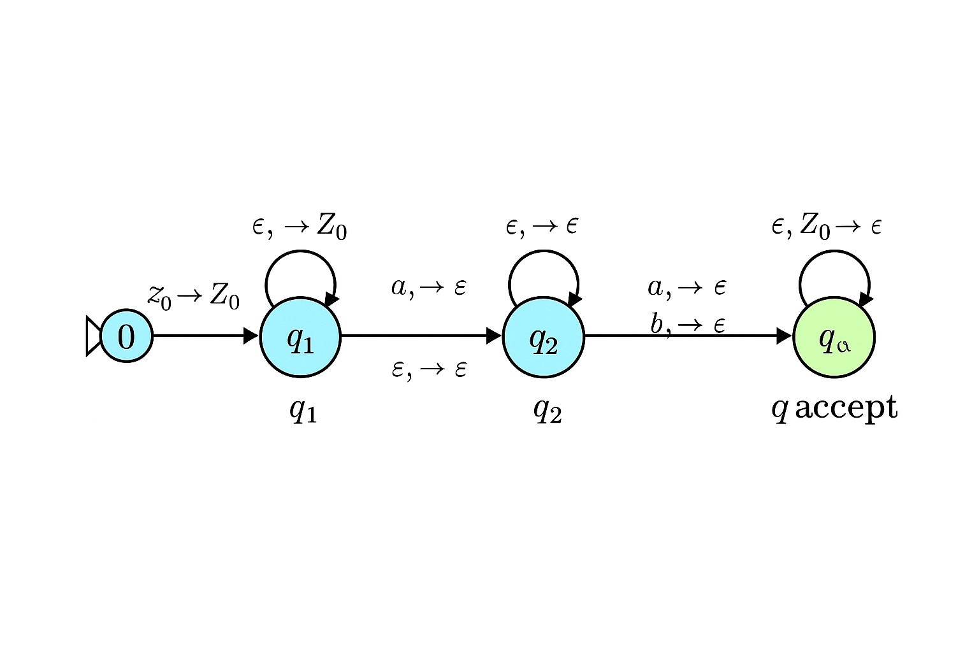

6) Turing Machines

Introduction
A Turing Machine (TM) is a theoretical model of computation consisting of:
- A finite set of states (including an initial and one or more accepting states).
- A tape divided into cells, each holding a symbol from the tape alphabet.
- A head that reads and writes symbols and moves left or right.
- A transition function that determines the next state, symbol to write, and head movement.
A string is accepted by a TM if, starting from the initial state and reading the input on the tape, the machine eventually enters an accepting state.

Given TM Description
- States: I (initial), J, K, L, M, F (final).
- Transitions:
I → J on c/c,R
J loops on a/x,R; J → K on b/ε,L
K loops on blanks and b; K → L on x/ε,R
L loops on blanks and c; L → M on b/ε,L
M loops on blanks; M → F on x/x,R
- Tape symbols: {a, b, c, x, ε}
- Input alphabet: {a, b, c} (since x and ε are internal markers).
The machine marks a as x, checks for b and c in a specific order, and halts when conditions are satisfied.

A. Three 4-letter words accepted by this TM
To be accepted:
- The first symbol must be c (I → J).
- There must be at least one a (to mark as x).
- There must be at least one b and another c (to trigger transitions to K, L, M).
Examples (with reasoning):
- cabc
Starts with c → J
a replaced by x → J
b triggers move to K → L → M → F
- cbac
Contains all required letters; same reasoning.
- cabc (or cbca)
Any permutation where first letter is c and all three letters appear.

B. Three 4-letter words NOT accepted by this TM
Rejected if:
- Missing a, b, or c.
- Does not start with c.
Examples:
- aaaa → No c at start; TM stuck at I.
- bbbb → No c or a; cannot proceed.
- ccaa → Missing b; cannot reach M → F.

C. Description of words accepted by this TM
The TM accepts words that:
- Start with c.
- Contain at least one a and one b (so transitions to J, K, L, M occur).
- Include another c somewhere (to allow L’s loop).
Formal description: $ L = { w \in {a,b,c}^* \mid w \text{ starts with } c \text{ and contains } a,b,c } $

D. Alphabet of the language accepted by this TM
The input alphabet is: $ \Sigma = { a, b, c } $ (x and ε are tape symbols used internally, not part of the input alphabet.)

Summary Table
Part | Answer
A | cabc, cbac, cbca
B | aaaa, bbbb, ccaa
C | Words starting with c and containing a, b, and c
D | {a, b, c}

7) Turing Machines with input and output

Problem Restatement
I have a Turing Machine (TM) that accepts words over the alphabet
$\Sigma = {a, b}$
where the word contains an even number of a's and b's. The task is to transform this TM so that:
- If the word is accepted:
  - The output tape head is positioned over the first letter of the input.
  - All letters a are replaced by x.
- Example:
Input: aabbaa
Output tape: [x]xbbxx (head over the first x).

Step 1: Understanding the Original TM
- The original TM checks for even number of a's and b's.
- It likely uses states to track parity:
q0: even a's, even b's (start and accept state).
q1: odd a's, even b's.
q2: even a's, odd b's.
q3: odd a's, odd b's.
- Transitions:
Reading a toggles between even/odd a states.
Reading b toggles between even/odd b states.

Step 2: Required Transformation
We need to extend the TM with two new behaviors:
- Replace all a's with x.
- Move head back to the first symbol after processing.
This means:
- After acceptance, enter a new phase:
  - Phase 1: Move head to the leftmost position.
  - Phase 2: Replace all a with x while scanning.

Step 3: Design of the Modified TM
New Components
- Original states: q0, q1, q2, q3 (parity check).
- New states:
qAccept: Enter after acceptance.
qLeft: Move head to the leftmost cell.
qReplace: Replace a with x while moving right.
qDone: Final state with head on first symbol.

Algorithm
- Phase 0 (Original TM):
Process input to check parity.
If accepted, go to qAccept.
- Phase 1 (Move Left):
From qAccept, move left until blank (_).
Transition to qReplace.
- Phase 2 (Replace):
Move right:
    - If a, write x.
    - If b, keep b.
Stop when blank is reached.
Move back to first symbol → qDone.

Step 4: Formal Transition Sketch
- qAccept → qLeft: _/_, L
- qLeft → qReplace: after reaching blank, move right.
- qReplace:
  - a/x, R
  - b/b, R
  - _/_ , L → qDone
- qDone: Move left until first symbol.

Step 5: Example Execution
Input: aabbaa
- Original TM accepts (even a's = 4, even b's = 2).
- Move left → reach blank.
- Replace phase:
  - a → x, a → x, b → b, b → b, a → x, a → x.
- Final tape: xxbbxx with head on first x.

Step 6: Why This Works
- The original acceptance logic is preserved.
- The transformation adds a deterministic cleanup phase.
- Head positioning and symbol replacement are guaranteed.

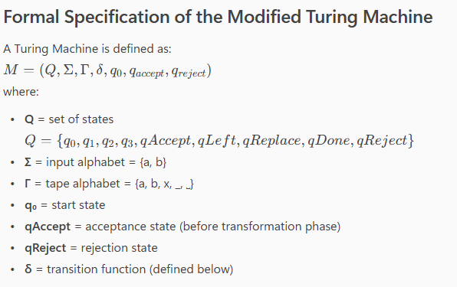

Transition Table for TM
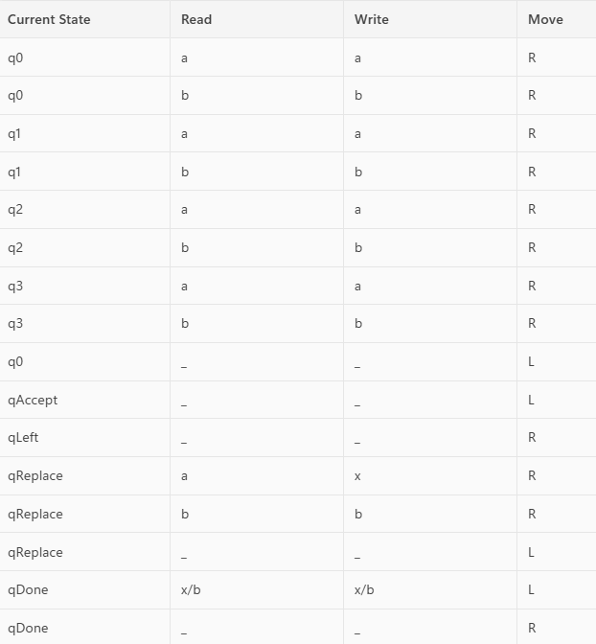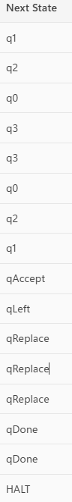

8) Decidability
Decidability and Turing Machine Design
Problem Statement
Given a C++ program that:
- Accepts a string over the alphabet $\Sigma = {a, b}$,
- Counts the number of occurrences of the letter 'b',
- Converts that count to binary,
- Outputs the binary representation,
Design a Turing Machine (TM) that performs the same operation.

1. Understanding the C++ Program
The C++ code performs the following steps:
std::string str;
int count = 0;
std::cin >> str;
for (char c : str) {
if (c == 'b')
count++;
}
std::string binary = "";
while (count > 0) {
binary = std::to_string(count % 2) + binary;
count /= 2;
}
std::cout << binary << std::endl;
Summary of Logic
- Input: string over $\Sigma = {a, b}$
- Count: number of 'b's
- Convert: count to binary
- Output: binary string

2. Turing Machine Overview
A Turing Machine (TM) is defined as:
$ M = (Q, \Sigma, \Gamma, \delta, q_0, q_{\text{accept}}, q_{\text{reject}}) $
Where:
- $Q$: finite set of states
- $\Sigma = {a, b}$: input alphabet
- $\Gamma$: tape alphabet (includes $\Sigma$ and symbols like X, 0, 1, #, □)
- $\delta$: transition function
- $q_0$: start state
- $q_{\text{accept}}$: accept state
- $q_{\text{reject}}$: reject state

3. TM Design Strategy
I divide the TM into three phases:
Phase 1: Count 'b's
- Scan input from left to right.
- For each 'b', increment a unary counter at the end of the tape (e.g., write X).
- Mark processed characters to avoid reprocessing.
Phase 2: Convert Unary to Binary
- Use repeated division by 2.
- Store remainders (0 or 1) in a separate tape section.
- Reverse the binary digits to get correct order.
Phase 3: Output Binary
- Move to the start of binary section.
- Print the binary digits.

4. Formal TM Construction
Tape Alphabet
$\Gamma = {a, b, X, Y, 0, 1, □, #}$
States
- $q_0$: start
- $q_{\text{scan}}$: scan input
- $q_{\text{count}}$: increment unary counter
- $q_{\text{convert}}$: convert unary to binary
- $q_{\text{output}}$: write binary
- $q_{\text{accept}}$: halt and accept

5. Example Execution
Input: abbab
- Count of 'b's = 3
- Unary counter: XXX
- Binary conversion:
  - 3 ÷ 2 = 1 remainder 1 → write 1
  - 1 ÷ 2 = 0 remainder 1 → write 1
- Output: 11

6. Decidability Analysis
This problem is decidable because:
- The TM halts for all inputs.
- It performs a finite number of steps.
- It produces a deterministic output.
Why Decidable?
- The language of strings over ${a, b}$ is regular.
- Counting and binary conversion are computable functions.
- The TM always reaches a halting state.

7. Academic Justification
This TM design aligns with the Chomsky hierarchy:
- Regular languages → Finite State Automata
- Context-free languages → Pushdown Automata
- Computable functions → Turing Machines
Since the task involves counting and arithmetic, it requires a TM rather than an FSA or PDA.

Conclusion
We have constructed a Turing Machine that:
- Accepts strings over ${a, b}$,
- Counts the number of 'b's,
- Converts the count to binary,
- Outputs the result.
This problem is decidable, and the TM halts with correct output for any valid input.

Formal Definition of the TM
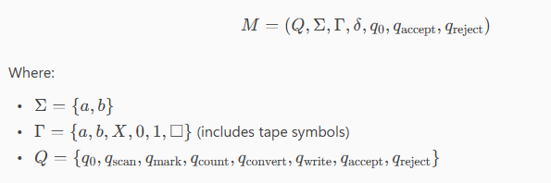

Turing Machine Transition Table
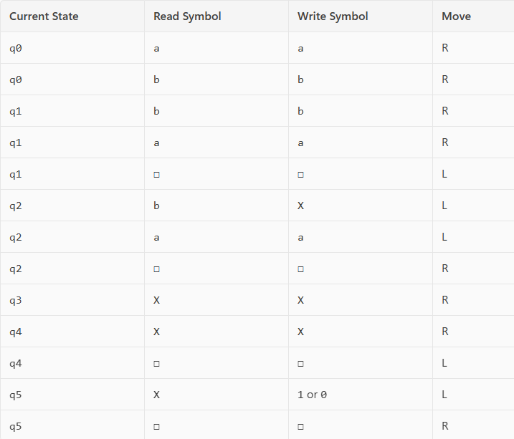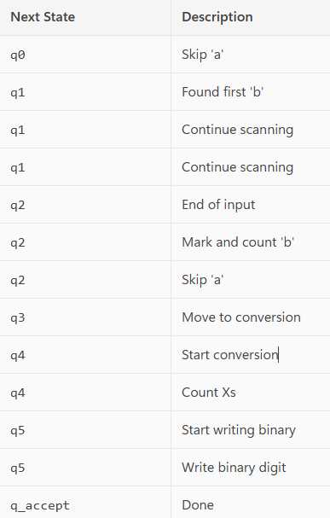

State Diagram
